**IFTTT trigger from VERA**

You need to use the IFTTT service webhooks

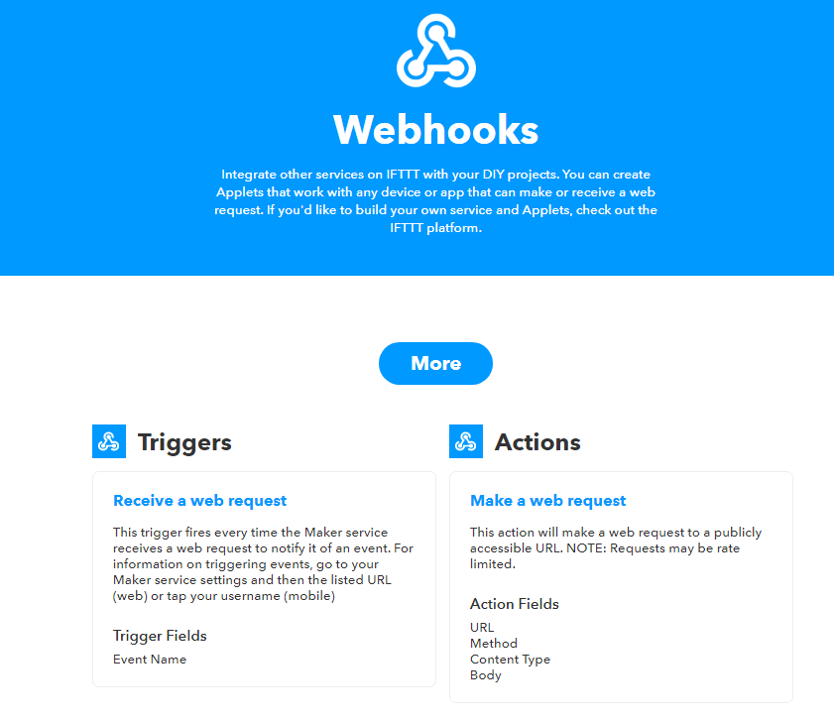

You can create an IFTTT applet like this :

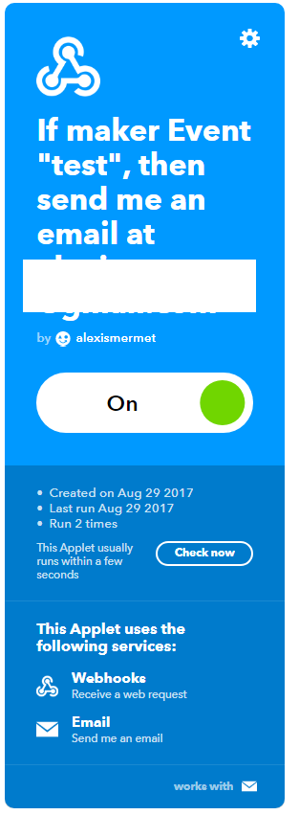

If you go into Settings :

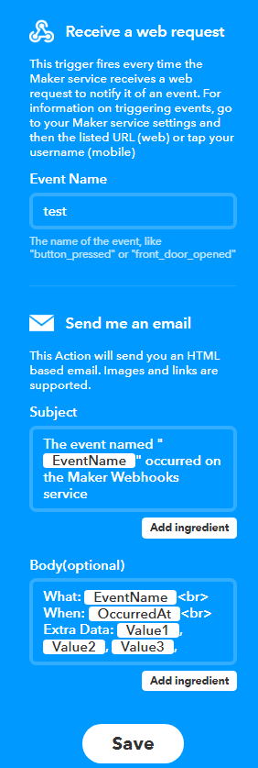

You need to determine the URL to call for the webhook. It is in the documentation page

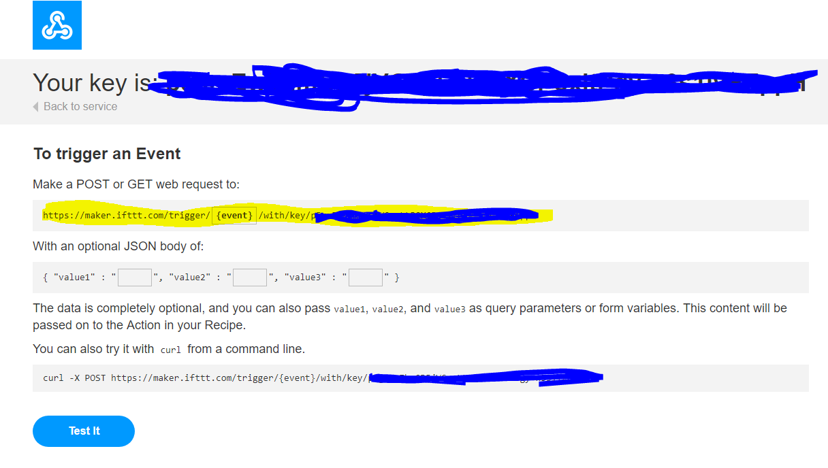

Trigger the event from LUA this way. Result is visible as the content is returned by IFTTT and I do receive the email message that was part of my IFTTT applet action

( ALTUI test lua code window screen shot )

